PR03: Referential Integrity
With Restricted and Cascade Constraints

Overview
      - In this exercise, you will download the “PR3.1School_PKFK” file.
      - Use SSMS with the account and connect to MS SQL Server IP: 163.17.9.18.
      - In a relational database, every table must have a Primary Key (PK), which serves as a unique identifier for each record (row) within that table.
      - A Foreign Key (FK) is a column or a combination of columns in a table that establishes a relationship between the data in two tables.
      - Referential Integrity Constraint enforces that the values stored in the child table correspond to existing values in the parent table. This constraint protects the database from inconsistent or invalid relational data.
      - Understanding the action rules of the Referential Integrity Constraint
  - Referential Integrity is maintained when a foreign key in a table references the primary key of another table.
  - The values in the foreign key column must either match an existing primary key in the referenced table or be NULL.

Types of Referential Integrity Constraints
Three common approaches are used to enforce referential integrity:
- Restriction (Restrict Rule): Prevents actions that would violate referential integrity. The system rejects any attempt to delete or update a referenced primary key if dependent records exist in related tables.
- Cascade (Cascade Rule): Automatically propagates changes from the referenced record to the dependent records. If a primary key is updated or deleted, corresponding foreign key values in related child tables are also updated or removed accordingly.
- Nullify (Set Null Rule): When a referenced primary key record is modified or deleted, the associated foreign key values in child tables are set to NULL, effectively removing the link while preserving the child records.

III. Logical Relational Schema

The Logical Relational Schema shown in the image represents a relational database structure with multiple tables and their relationships, ensuring referential integrity constraints through Primary Keys (PKs) and Foreign Keys (FKs).
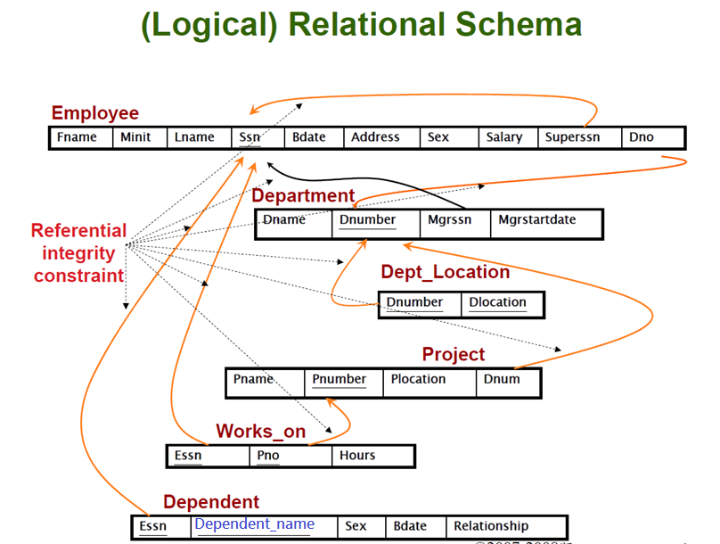
This relational schema properly structures one-to-many (Employee-Department), one-to-one (Department-Manager), and many-to-many (Works_on) relationships while maintaining data integrity across tables. Below is a breakdown of the schema:

1. Employee Table
- PK Attributes: “Ssn” is referenced by other tables and is a self-referencing foreign key in the same table.
- Two Relationships:
  - “Dno” (FK) links to the Department table (Dnumber).
  - Employee-Supervisor Relationship: “Superssn” (FK) represents a self-referencing foreign key referencing the primary key “Ssn”.

2. Department Table
- PK Attributes: Dnumber.
- Two Relationships:
  - “Dnumber” is referenced by two tables Dept_Location and Project.
  - “Mgrssn” (Manager's Social Security Number) is a foreign key referencing Employee(Ssn).

3. Dept_Location Table
- PK Attributes: (Dnumber, Dlocation).
- Relationships: “Dnumber” is a foreign key referencing Department(Dnumber).

4. Project Table
- PK Attributes: Pnumber.
- Relationships: Dnum is a foreign key referencing Department(Dnumber).

5. Works_on Table
- Many-to-Many Relationship between Employee and Project.
- Attributes: Essn (FK referencing Employee's Ssn), Pno (FK referencing Project's Pnumber), Hours.
- Ensures an Employee can work on multiple projects and each project can have multiple employees.
- In database design, an attribute that acts as both a Primary Key (PK) and a Foreign Key (FK) is typically found in child tables within a 1:1 relationship or as part of a composite primary key in a bridging table. These attributes, sometimes called Primary Foreign Keys (PFK), are essential for maintaining referential integrity while ensuring uniqueness within the child table

6. Dependent Table: stores dependent information for employees.
- Attributes: Essn (FK referencing Employee's Ssn), Dependent_name, Sex, Bdate, Relationship.

IV. Important Characteristics of the Foreign Key
- A foreign key (FK) in a child table must either match an existing value in the referenced primary key (PK) of the parent table or be NULL.
- A foreign key (FK) enforces referential integrity by ensuring that all values in the child table either exist in the parent table's primary key (PK) or are set to NULL.
- A foreign key (FK) must either hold a value that exists in the referenced primary key (PK) or be NULL, ensuring referential integrity.
- A foreign key (FK) can reference the primary key (PK) within the same table, which is known as a self-referential foreign key or self-reference.
- A foreign key (FK) may reference a primary key (PK) from a different table, establishing a cross-reference between tables.
- Unlike primary keys, foreign keys (FKs) do not need to be unique in the child table.
- Foreign keys (FKs) can contain duplicate values, meaning multiple rows in the child table can reference the same primary key in the parent table.
- The column name of a foreign key (FK) does not have to be identical to the primary key (PK) it references, though using similar names improves clarity and consistency.
- When visualizing referential integrity in diagrams, an arrow should originate from the foreign key in the child table and point to the corresponding referenced primary key in the parent table.
- A single primary key can be referenced by multiple foreign keys across different tables.
Question 3.1 ~Question 3.6:

V. Creating Relations and Establishing Their Relationships
[Method 1] Use SQL script to Define Relations and Relationships
- Completing the SQL Script
Download the “PR3.1School_PKFK” file and fill in the necessary details to create four tables, define a primary key for each table and then define three foreign keys to establish the relationships that associate the “Classes” table with “Courses”, “Instructors”, and “Students” tables, respectively.

- Use the “Database Diagrams” function to visualise the Schema
Step 2-1. Each table has only one primary key (PK) to uniquely identify its records.
Step 2-2. The Classes table establishes 3 foreign keys (FK) referencing their parent tables: Each pair of relations (Courses and Classes), (Instructors and Classes), and (Students and Classes) has FK references to its parent table’s PK.
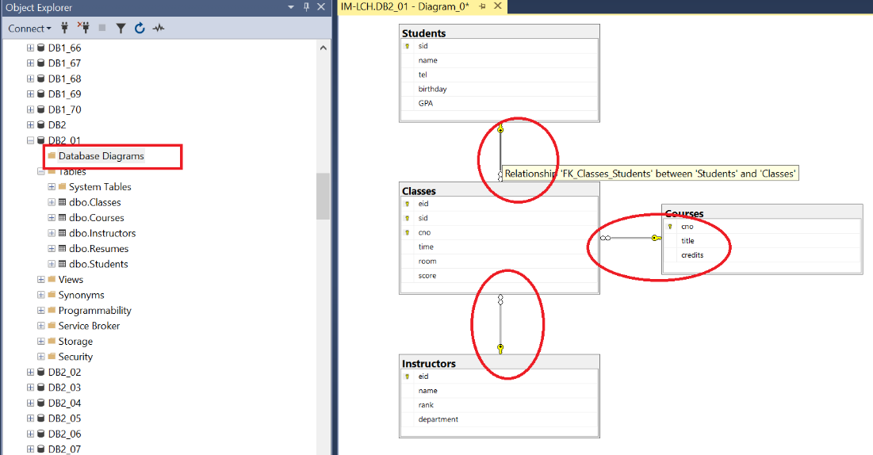

- Identify Special Attributes with Dual Roles (PK & FK)
- Observe that certain attributes in a table serve as both a primary key (PK) and a foreign key (FK).
- As a Primary Key (PK): It ensures that each row in the child table is unique and cannot contain NULL values, thereby enforcing Entity Integrity.
- As a Foreign Key (FK): It links to a primary key in a parent table (e.g., ParentID in Table A links to ParentID in Table B), enforcing Referential Integrity.
In this case, "Classes" is the child table that connects the three parent tables (Courses, Instructors, and Students), containing attributes that act as both PK and FK.

Question 3.7
[Method 2] Use MS SSMS to create primary keys and their relationships:
- Execute the “PR3.1School_PKFK” file.
Step 4.1 Right-click the “Classes” table.
Step 4.2 On the “Design” tab, press the Shift button + choose three attributes ( eid, sid, cno), Right-Click “Set Primary Key”. Next, observe the primary key constraint.
Step 4.3 Press Function Key Ctrl+F4 and SAVE the setting, then close the structure.
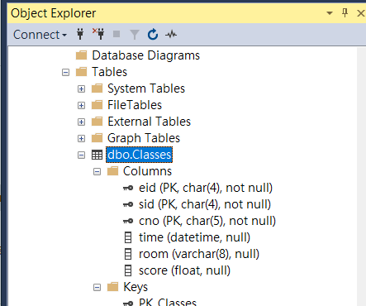
Step 4.4 Repeat Steps 4.1 to 4.3 to set the primary keys for the Courses, Instructors, and Students tables.
Step 4.5 Right-click the “Classes” table.
Step 4.6 On the “Design” tab, right-click the “Relationships…”, click “Tables and Columns Specification”, and click Add. Refer to the following steps and make your changes.
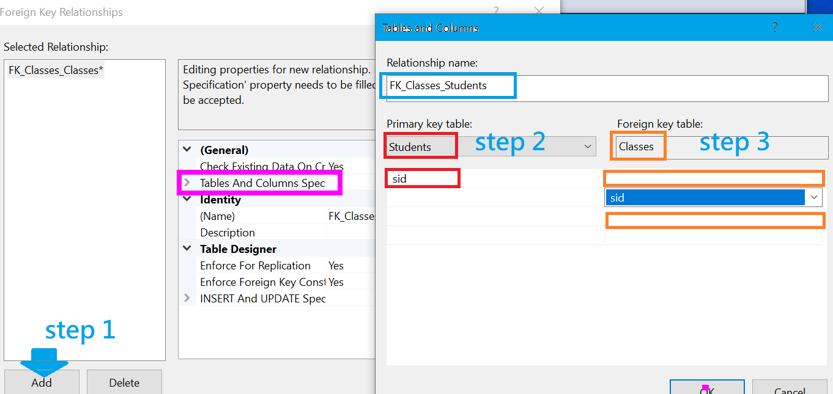
Step 4.7 Press Function Key Ctrl+F4 and SAVE the relationship setting of the “Classes” table with the other three tables which are students, instructors, and courses, then close the structure of the “Classes” table.

IV. Three possible causes of violation of the Referential Integrity Constraint
Step 5. Use the syntax【select * from table_name】to observe the data contents of the “Instructors” table..

【Note】In the “Instructors” table, the tuple ('E003', 'Amy Wang', 'Professor', 'MATH'), dentifies Amy Wang by her unique ID 'E003'. Meanwhile, within the "Classes" table, 'E003' appears three rows, indicating that she teaches those courses.

To link the “Instructors” and “Classes” tables, the “eid” field in the “Classes” table is defined as a foreign key so that these instances can be related to the corresponding tuple with the primary key “eid” in the “Instructors” table.
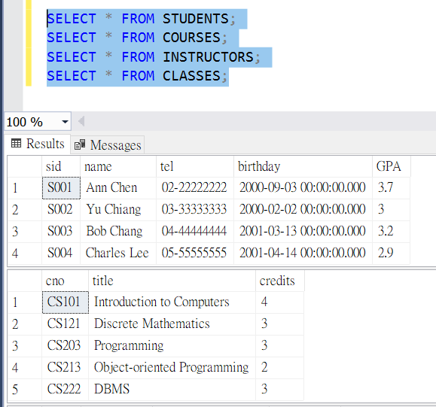 | 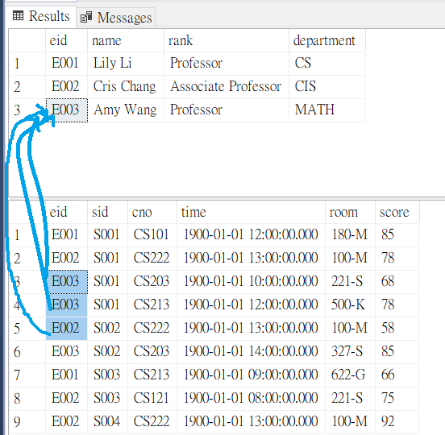

Case-01: Insertion into a Referencing Child Relation (table)
- The referential integrity constraint ensures that a foreign key in the child table can only hold values that already exist as primary keys in the parent table.
- If a value is inserted into the foreign key column that does not correspond to any existing primary key in the parent table, it will violate the referential integrity constraint and result in an error.

- Example-
Consider the two relational schemas: the “Classes” table references the “Students” table. Here,
Question 3.8: Write a SQL statement to insert a new tuple below into the "Classes" table and observe the error below.
('E001','S007','CS101','12:00:00','180-M', 80);

In the “Classes” relation (table), we CAN NOT insert any student having sid as 'S007'. This is because the student ID as 'S007' is absent in the “Students” relation (parent table).

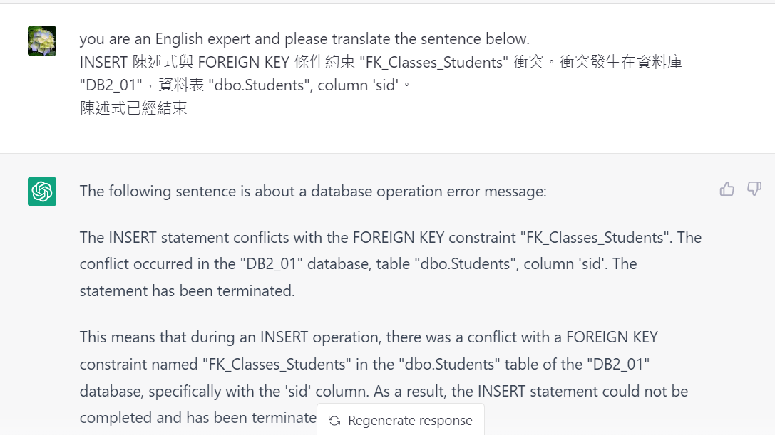

Case-02: Deletion from a Referenced Relation (Parent Relation)
- It is not allowed to delete a row from the parent relation (table) if the foreign key uses the value of the referenced primary key attribute.
- Such a deletion operation will violate the referential integrity constraint.

Example: Consider the two relational schemas: the “Classes” relation (table) references the “Students” relation (table).
Question 3.9:
Question 3.10: Write a SQL statement to delete the tuple with eid ='E003' from the “Instructors” table and observe the error below.

scenario: Here, assume that professor 'Amy Wang' with ID as 'E003' decides to retire. So her information should be removed from the school’s DB.
- Even under the circumstances, we CAN NOT delete the tuple from the “instructors” relation (table) having instructor ID as 'E003'.

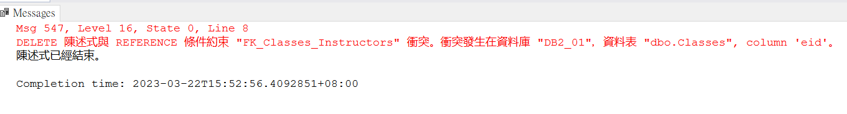
- If a deletion were allowed, it could result in orphan records—rows with foreign key values that no longer match any primary key in the related table.
To avoid this, referential integrity constraints are enforced to maintain consistent relationships between the “classes” and “instructors” tables.

IV. Three Constraints in DBMS for Enforcing Referential Integrity
- Restrict constraint for Referential Integrity
- Cascade constraint for Referential Integrity
- Nullify constraint for Referential Integrity

In SQL Server, there are FOUR specifications associated with referential integrity constraints:
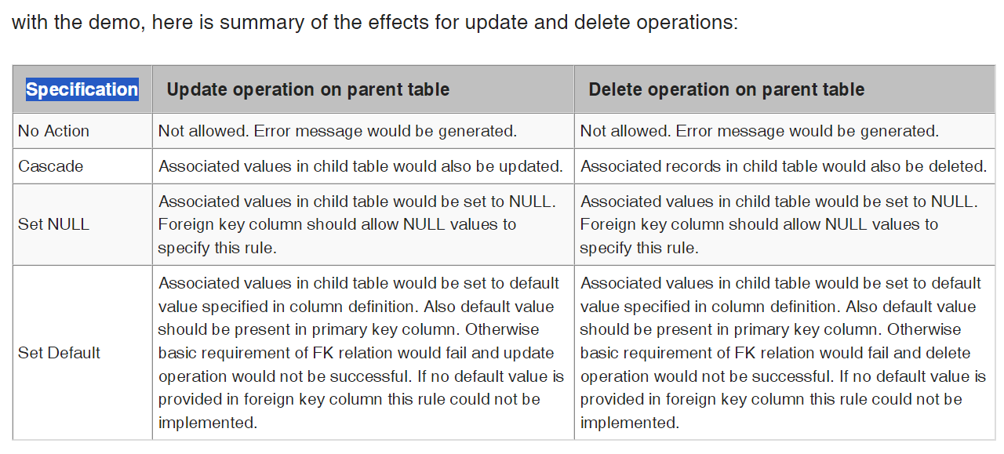
Question 3.11: Please observe the “Deletion Rule” and “Update Rule” under the "INSERT and UPDATE specifications" in SQL Server.

Step 6: Using the SQL Server Management Studio GUI.
Observe the relationship of the “Instructors” and “Classes” tables.
Step 6.l: Right-click the “Classes” table.
Step 6.2: On the “Design” tab, right-click the “Relationships…”, and click “Tables And Columns Specification”.
Step 6.3: Observe the “Deletion Rule” and “Update Rule” under the "INSERT and UPDATE specifications," as shown below.
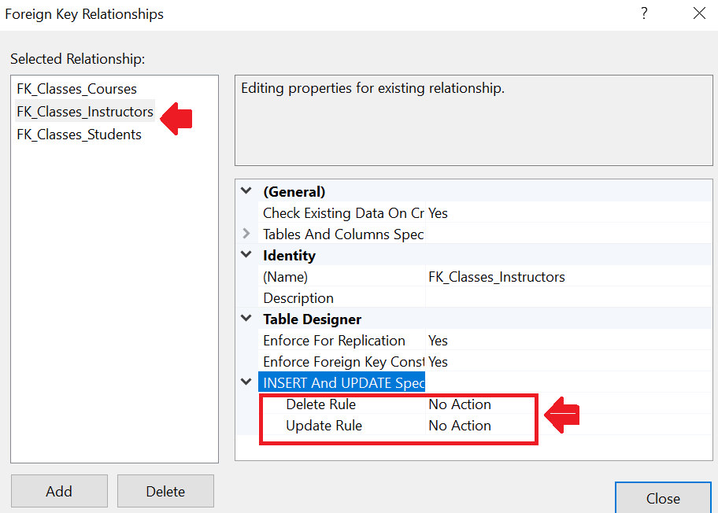
Step 7: In the "INSERT and UPDATE specifications", select “Cascade” mode for “Deletion Rule” and “Update Rule”.
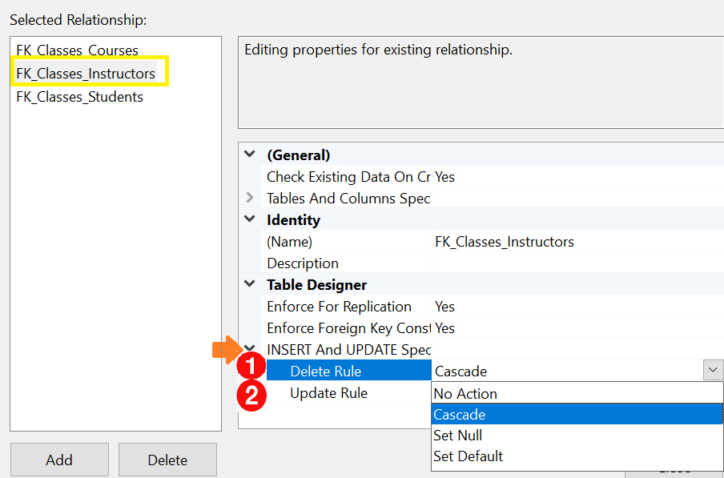
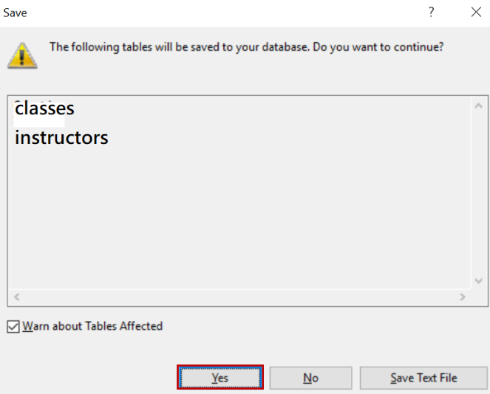 | 【Note】SAVE: Click on Close and save the table in the designer. Click Yes in the warning message window. Once you click on Yes, a foreign key with a delete rule is created. Similarly, we can create a foreign key with the UPDATE CASCADE rule by selecting CASCADE as an action for the update rule in INSERT and UPDATE specifications.

Step 8: Perform the delete operation again to delete the information of Professor "Amy Wang" from the “Instructors” table. When a database management system (DBMS) manages the relationships between tables, we have changed the restricted mode to the cascaded mode, which enforces the referential integrity constraint for both update and delete.

Question 3.12: Show the data contents of “Instructors” and “Classes” relations (tables).

      - Step 9: Execute the “PR03.3eng_School(restriction mode).sql” file.
At this stage, the four tables exist but are not yet connected by any relationships, as shown in the diagram below.
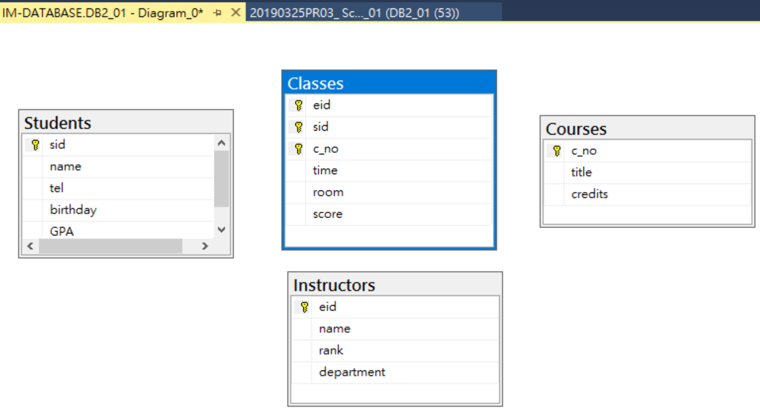

Question 3.13: How to use SQL syntax to define foreign key constraints with the CASCADE option to establish the relationships between (courses and classes), (students and classes) and (instructors and classes) tables.

ON DELETE CASCADE
ON UPDATE CASCADE

